Business Plan 2022-2023
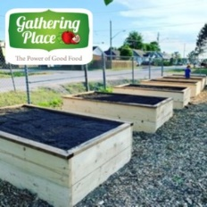
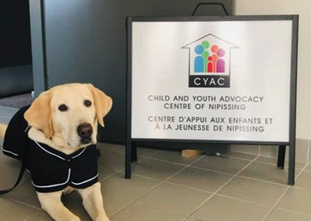
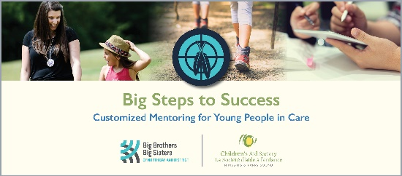
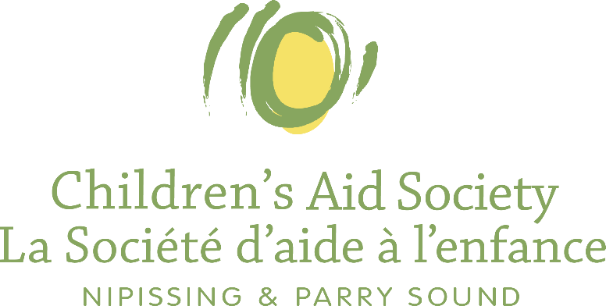

MANDATE AND STRATEGIC DIRECTION
The Children’s Aid Society of the District of Nipissing and Parry Sound (the Society) is a child protection agency mandated under the Child, Youth and Family Services Act. Under this mandate the Society has the responsibility to protect children from harm or the risk of harm due to neglect and physical, sexual or emotional abuse.
Children’s Aid Societies are independently governed agencies that are responsible for providing mandatory critical services. They are legislated to perform certain functions which includes:

- Investigate allegations or evidence that children who are under the age of sixteen years or in the society’s care or are under its supervision may be in need of protection;
- Protect, where necessary, children who are under the age of eighteen years or in the Society’s care or under its supervision;
- Provide guidance, counselling and other services to families for protecting children or for the prevention of circumstances requiring the protection of children;
- Provide care for children assigned or committed to its care under the Act;
- Supervise children assigned to its supervision under the Act;
- Place children for adoption under Part VII; and
- Perform any other duties given to it by this or any other Act.

This legislation and the supporting regulations, directives, and standards prescribe specific and detailed requirements for what services Children’s Aid Societies must provide, how they must provide these services, including services to Indigenous children and families and French language services, as well as timelines in which these mandatory services must be provided.

RECONCILIATION AND ACKNOWLEDGEMENT
The Society remains steadfast in our commitment to honour the Truth and Reconciliation Commission’s Calls to Action and the nine commitments made by child welfare agencies across Ontario.

Reconciliation with Indigenous Peoples remains a priority for the Society. Staff, foster parents and board members continue to learn about the experience of oppression by Indigenous families.

The history and impact of child welfare policy and practices on Indigenous people has created a divide and mistrust that is deeply ingrained and threads through multiple generations. With targeted practices related to Colonization and the passing of law, Indigenous people have been marginalized, segregated and left dependent on the government and its institutions.

Children’s Aid Societies are deeply concerned at the over-representation of Indigenous children in care and the critical feedback from Indigenous communities about the negative impact that the current system has on Indigenous children, families, and communities.

The Ontario Association of Children’s Aid Societies (OACAS) and child welfare agencies across Ontario have worked to evolve a number of priorities in support of Indigenous child welfare and improving services to Indigenous families while trying to mitigate the over-representation of Indigenous children on current caseloads.

Niijaansinaanik Child and Family Services was designated by the Ministry to provide child protection services on April 1, 2021. The Society worked with Niijaansinaanik Child and Family Services to support their designation process including protocol development, data collection, providing connects to other service providers and employee mentoring.

As work continues in the sector to fulfill the commitments made towards Truth and Reconciliation, the Society has taken steps to further the achievements of Truth and Reconciliation and will continue to explore opportunities to build and enhance existing relationships with Indigenous
communities.

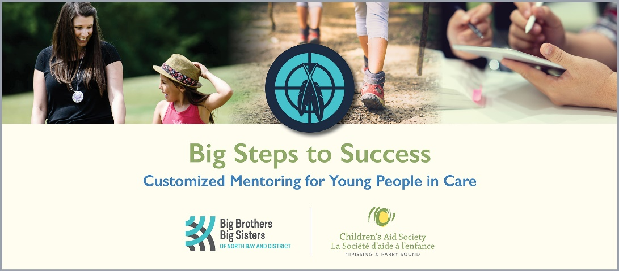

Equity
Race and ethnocentric services are provincial and local priorities, as the child welfare sector works to advance strategies and frameworks to support providing culturally appropriate services and center decisions, practices and relationships around a framework of equity and inclusivity.

The Society has established an Anti-Oppression committee to guide our practices through an equity lens.

The Society has continued to place a focus on understanding the unique identity and experiences of service recipients and has implemented Identify Based Data Collection practices.

Overview of Current and Future Programs and Key Activities

Current: The Children’s Aid Society is a multi-service agency offering programs funded through the Public Health Agency of Canada (Canada Prenatal Nutrition Program, Community Action Program for Children), Ministry of Youth Justice Services and Department of Justice Canada (Community Support Team, Child and Youth Advocacy Centre), and Ministry of Community, Children and Social Services (Child Welfare, Infant and Child Development, Community Capacity Building, Child and Family Intervention).

Within each of these programs we offer a wide variety of evidence-based services that are trauma-informed, inclusive, and person-centered including but not limited to;
- The Circle of Security Program
- Arbour House (a crisis and stabilization home for youth 12-18)
- Mothers In Mind (2014-2016, re-applying for 2022)
- The F words for Family Focused Assessments in Early Intervention
- The ARC Framework
- Functional Family Therapy
- Zones of Regulation
- Triple P Parenting (in partnership with the local health unit)
- Neurosequential Model of Brain Development Tools and Assessments
- Attachment Focused Parenting Training and Service Approaches

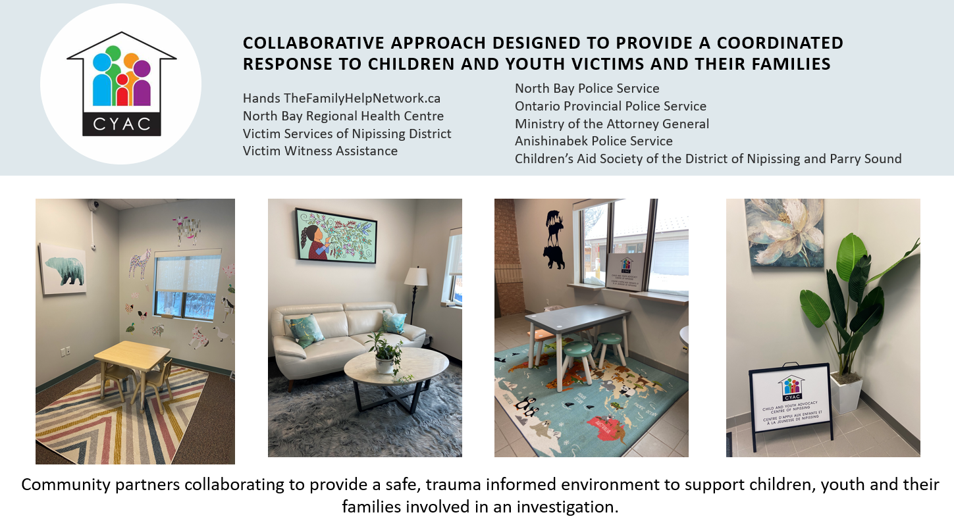

Strategic Directions and Priorities 2021-2025
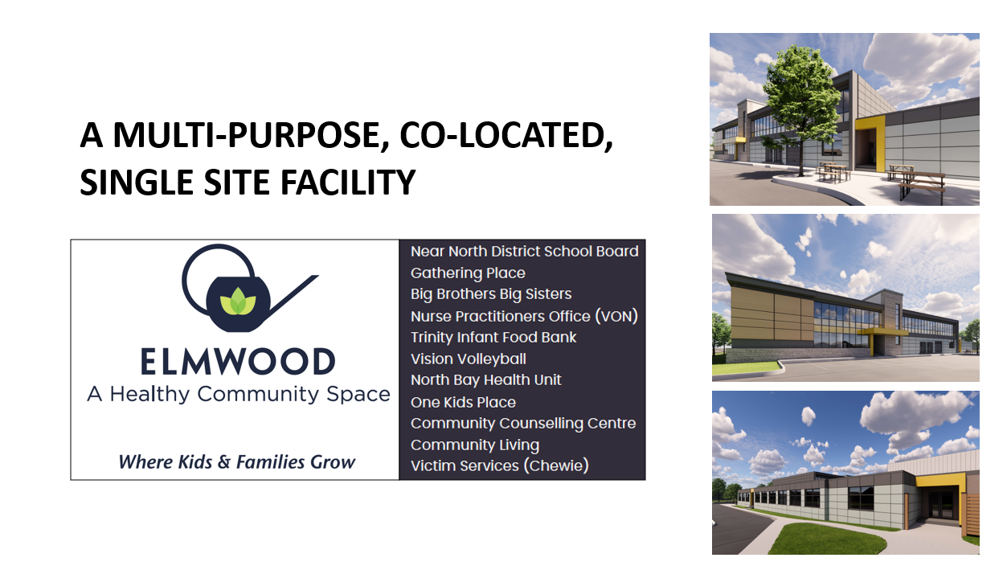
Future: The Society is engaged in a number of projects that will unfold during the life of our current strategic plan which extends to 2025 including Signs of Safety Implementation, (currently in year 1, an evidence based Child Protection Service Framework), Connect your Rhythm (an internally

developed Infant Mental Health Screening and service delivery model using the Devereaux Early Childhood Assessment) and Big Steps to Success (a mentorship program specifically designed for children and youth living in government care).
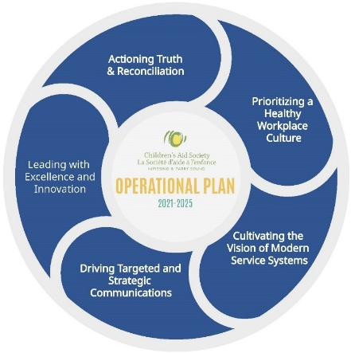
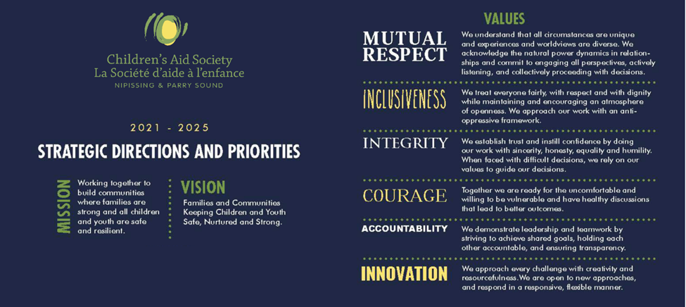

Strategic Commitments, Key Activities, Targets and Mitigation Plans

Strategic Priority | Commitments | Objective/Goal | Project and/or Committee that Supports the Goal | Person(s) Responsible | Reports To | Time Line for Completion | Mitigation Plan (MP) | Q1 Baseline
Health and Wellness | Health and well-being | Efficiently action the recommendations and report findings from the Wellness Committee regarding the bi-annual staff wellness survey | Wellness Committee, QA, Sr. Mgmt | Wellness committee | Director of Corporate Services | Bi-Annually | Mitigation revolves around man power and uptake, alternative committee could assist in ownership, man power could be divested internally. | 15%
 | Health and well-being | Prioritize inclusivity and innovation for wellness through existing and new committees, initiatives, and partnerships. | Anti-Oppression Committee, Wellness Committee | Human Resources, Equity Lead. | Executive Director | Ongoing | Cost drivers may impact hiring of equity lead and what can be adopted as a new program. No MP in deficit year. | 20%
 | Leadership | Use existing leadership integration captured through Performance appraisals to facilitate succession planning conversations | Human Resources/QA/Sr Mgmt | HR Coordinator/QA | Executive Director | Yearly | Consistent completion of Performance appraisals required, Performance related mitigation plan. | 15%
Actioning Truth and Reconciliation | Niijaansaanik | Through Niijaansinaanik’s leadership we will continue to work alongside their agency by being a responsive and supportive partner. | Designation Committees and Secondment Supervisors | Supervisors and Senior Managers | Executive Director | Ongoing | Essential requirement, no MP required. | 75%
 | Prioritizing Change | Continue to action and realize the commitments outlined by FNIM communities and OACAS. | QA, Anti-Oppressions Committee and Truth and Reconciliation sub-committee | Senior Management | Executive Director | Ongoing | Essential requirement, no MP required. | 75%
 | Partnerships | Strengthening our relationships and collaboration with the local FNMI Communities. | Truth and Reconciliation Committee | Senior Management | Executive Director | Ongoing | Essential requirement, no MP required. | 50%
Cultivating a modern service system | Advocacy | Strengthening our position as a leader, ensuring we are at the key tables to influence decisions and advocate on behalf of the children, youth and families we serve. | Provincial Committee representation: Provincial Executive Leadership Representation, Directors of Service, Finance Directors, Quality Assurance Provincial Network, Provincial Resource Working Group | Supervisors and Senior Managers | Senior Management | Ongoing | Consider requesting non-management support as a leadership Segway if management staffing becomes too lean | 50%
 | Partnerships | Continue to prioritize partnerships with community organizations that increase alignment, coordination, collaboration and integration. | Participation on community planning tables such as CYMH, HUB, Data Collaborative, CSP, CYAC, | Senior Management | Senior Management | Ongoing | Consider requesting non-management support as a leadership Segway if management staffing becomes too lean | 75%
 | Anti-Oppression | Celebrate diversity and integrate anti-oppression practices by operationalizing the agency's equity workplan | Anti-Oppression Committee, French Language Committee | Chairs of respective committees | Director of Service | Ongoing | Re-Prioritization of Director time | 25%
Driving Targeted and Strategic Communications | Communication Strategy | Regular review of agency communication workplan to improve and enhance dialogue internally and externally | Sr. Mgmt | Communications Facilitator | Executive Director | Quarterly | External Communication Supports | 50%
 | Impact and Awareness | Prioritize reducing the stigma of child welfare through outreach activities that promote awareness of the agency's mission, vision and values. | Itty bitty kindness committee | Communications Facilitator | Executive Director | Ongoing | External Communication Supports | 50%
 | Impact and Awareness | Building stronger connections across departments levels and location, bringing staff together under a common mission and vision. | Senior management | Communications Facilitator | Executive Director | Ongoing | Internal Committee Assistance | 20%
Leading with Excellence and Innovation | Fiscal Prudence | Finance to review service and staffing trends at senior management through regular review of Finance Workplan. | Sr. Mgmt, Finance | Finance Manager | Director of Corporate Services | Monthly | Shared Services or External Agency Support | 50%
 | Fiscal Prudence | Quarterly review of available federal and provincial benefits and subsidies to ensure we maximize government entitlements | Finance | Finance Manager | Director of Corporate Services | Quarterly | Shared Services or External Agency Support | 25%
 | Fiscal Prudence | Modernize finance integration within agency through operationalizing the finance workplan | Finance | Finance Manager | Director of Corporate Services | Quarterly | Shared Services or External Agency Support | 25%
 | Training and Professional Development | Integrate PA data across departments in order to identify priorities and leadership opportunities. | Human Resources, Service, Finance | Training Coordinator/ Director of Service/ Finance Manager | Director of Corporate Services | Yearly | Re-Prioritization of Director and Supervisor time | 50%
 | Training and Professional Development | Whole system implementation of the signs of safety framework across the agency. | Signs of Safety Committees | Project Coordinator | Director of Service | 3 years | Re-Prioritization of Director and SOS leads time | 15%
 | Accountability | Complete probationary, annual and transfer performance appraisals when specified. | Supervisors | Human Resources | Executive Director | Yearly | Performance Mitigation Plan | 50%
 | Accountability | Actioning compliance opportunities to ensure high quality service standards through regular review and analysis of compliance/service data. | QA, Sr Mgmt | Supervisors | Executive Director | Monthly | Re-Prioritization of Director and QA priorities | 50%
 | Accountability | Formalized feedback process for each service area within the organization including the voice of all stakeholders (staff and service recipients) | QA, All Departments | Supervisors, QA Supervisor | Director of Corporate Services | Yearly | Shared Services or External Agency Support | 25%
 | Leading with Innovation | Continue to build on community integration, connection and prevention | Beauchamp Hub, CYMH Priorities, Community Safety and well being plan, Child welfare Redesign | Project Facilitator | Senior Management | Quarterly | Re-Prioritization of Director and Facilitator time | 75%
 | Leading with Innovation | Integrate research and evidence into practice through innovative service solutions. | Protection, Child Care, Resource | Supervisors and Workers | Director of Service | Quarterly | Re-Prioritization of Supervisor time | 25%
 | Leading with Innovation | Continue to develop and enhance Kin/kith Services (finding, supporting, financial) | All departments | Director of Service, Kin Service Supervisor | Executive Director | Yearly | Re-align staff responsibilities wherever possible | 25%
 | Leading with Innovation | Changes to programming and/or practice will be structured through a formalized CQI process | QA, Supervisors | QA | Director of Corporate Services | Ongoing | Re-Prioritization of Director Time | 0%
 | Leading with Innovation | QA workplan to be reviewed regularly at Senior Management | QA | QA Supervisor | Director of Corporate Services | Quarterly | Re-Prioritization of Director Time | 25%
 | Leading with Innovation | Prioritize a clear and integrated clinical strategy for the agency to reduce OPR/OPI placements and costs | Supervisors | Senior Management | Executive Director | Ongoing | Essential requirement, no MP required. | 10%
 | Capital Build | Continue to grow the community concept of a capital building through ongoing discussions with the ministry and community partners. | One Site Advisory Committee | Director of Corporate Services | Executive Director | Yearly | Alternative funding/planning phases will be considered as a MP | 25%

Risks

In the development of this Business Plan, the Society considers many factors that may impact and influence the execution and ability to attain the objectives set out in the Strategic Plan.

Government Fiscal Restraint
Past and current governments have continued to message fiscal restraint. For the child welfare sector, this has meant no increase to overall funding envelope to support inflation costs, cost of living or increasing demands for compliance and reporting.

Socio-Economic Realities
There are many socio-economic factors that impact the work of child welfare both locally and provincially. Within the districts of Nipissing and Parry Sound there are key determinants that are, or may, impact child welfare service volumes under the current funding model. There are limited affordable housing options within the communities served and human trafficking and homelessness are evolving as a pressing social priority within the communities as well as inadequate access to key health services such as addictions support services, addiction treatment services, and consistent access to primary health care providers.

COVID-19 Pandemic
The COVID-19 Pandemic that started in March 2020 has had profound impacts on all communities, including the communities served by the Society. The ultimate impact is unknown however, the Society has observed through its service delivery the hard realities of the pandemic, which is leading to higher rates of addiction, poverty due to precarious employment, and increased mental health demand due to the impact of social isolation. Although the demand for service has not increased substantially, the demand and need for community services and supports is growing, leading to longer wait times for service.

Operational Performance
Community-based organizations like Children’s Aid Societies are challenged to operate under significant fiscal constraint. Efforts are ongoing to improve organizational performance and effectiveness through efficiencies, continuous improvement and shared service opportunities.

The Society understands the importance of measuring performance and outcomes for children and their families. Key Performance Indicators (KPIs) have been developed to best outline effectiveness in the delivery of mandated services and are publicly reported on the government of Ontario’s website. The Agency also follows ministry requirements related to Quality Improvement Plan reporting on compliance to child protection standards on a regular basis.

Agency Overview and Community Partnerships

Communities/Demographics
 | Nipissing | Parry Sound
Population | 83,150 | 42,824
Children/Youth | 20.4% population | 17% population
Median total income of households | $60,303.00 | $60,251.00
Children in low income homes | 17.7% | 18.1%
Minorities | 2.4% | 1.5%
Immigrants | 4.5% | 7.1%
Aboriginal Population | 14.2% | 7.4%
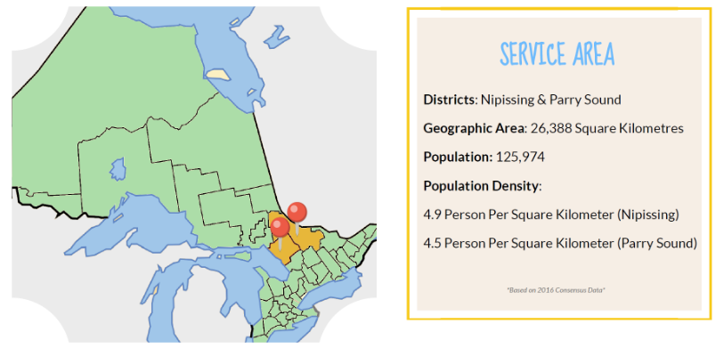

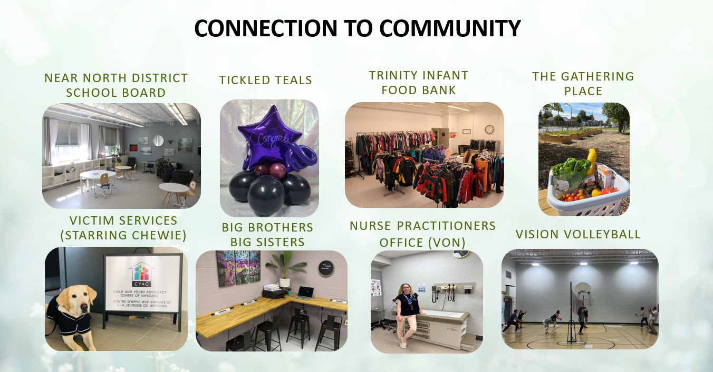

Financial Report
The Society exhausted all available funds from the Balanced Budget Fund in 2021, with the surplus being used to clear the historical deficit, and as such; has no further fund to offset expenditures this fiscal year. It is clear from the funding vs. net expenditures that while both revenue and expenditures are declining, there is a still a gap that needs to be reconciled in order for the Society to return to a balanced budget position.

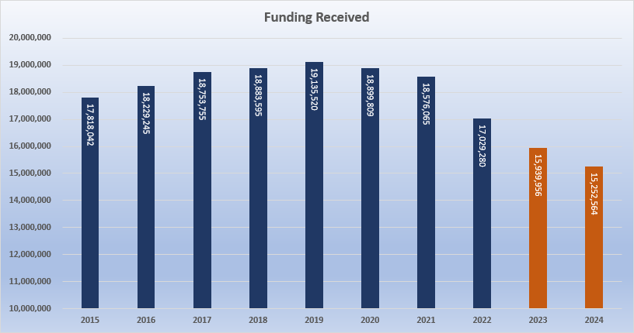

In terms of expenses, the Society’s expenses are broken down as follows with salaries and benefits and boarding costs representing 82% of the budget on an annual basis. As a human services organization, salaries and benefits remains the largest cost component for the Society. The Society continues to be mindful of the costs associated with staff, balanced against providing appropriate services to meet the mandate under the CYFSA.

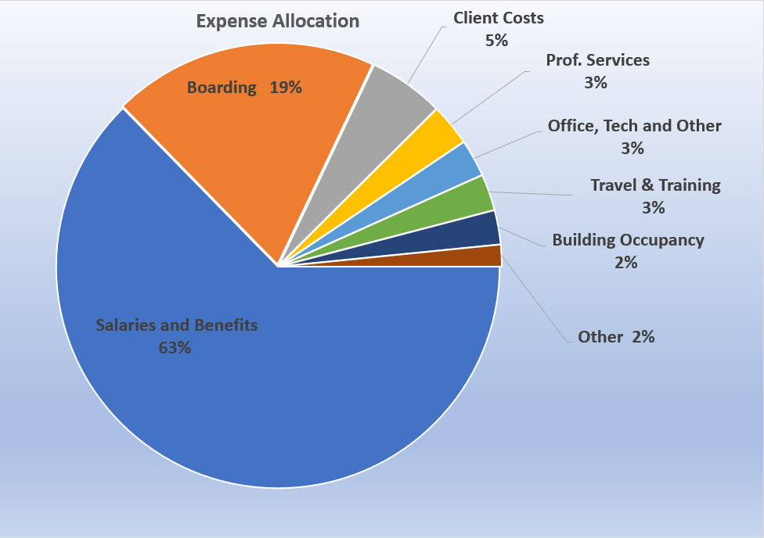

In addition to funding provided by the Ministry for delivery of services, the Society collects revenue from various sources including Children’s Special Allowances, Child Disability Benefit (for those children and youth who qualify pursuant to Canada Revenue Agency) and other available sources to secure funding for exceptional needs for children in care. The Society has implemented policies and processes to ensure the collection of revenues for eligible children.

Overview and Analysis of Operational Performance

Protection Services

The COVID-19 Pandemic created exceptional circumstances that have skewed data and service trends in child welfare. Due to closures of schools, childcare centers and community programs, several main sources of referrals disappeared; as a result, the Society experienced a decline in the number of referrals and investigations from 2019-2021 which have since climbed to more expected levels.

Residential Services

The Society has been steadily placing less and less children and youth into foster and group care by re-focusing our service efforts on increasing the use of family-based connections and placing youth in Kinship and Kith Service arrangements with relatives and/or family friends. Through a robust recruitment strategy commencing July 2022, the Society expects to expand our placement options in order to reduce the number of children and youth placed out of community and away from family.

Residential Placement Services Language (Quick Reference)
Children in Care of The Society | Children and/or Youth who were unable to maintain safety in the care of their primary caregiver
Continued Care and Youth Support | Youth over the age of 18 who still require Society care and support (voluntary)
Formal Customary Care | Out of home care that matches the child/youth with an Indigenous Care Provider.
Extended Society Care | Where the Society has gone to court to seek parental rights for a child/youth
Kinship Service | Out of home care that allows the child to live with extended family/kith

