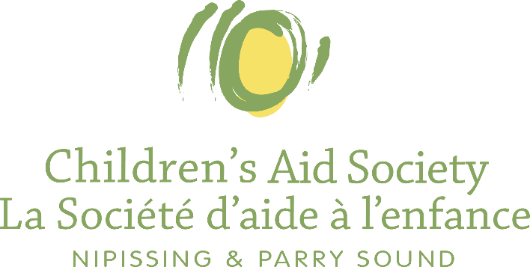
Beauchamp Community Hub
140 Elmwood Avenue, North Bay
youthprogramming@parnipcas.org
@thehubyouthdropin | (705) 472-0910
Beauchamp Community Hub
Beauchamp Community Hub
Beauchamp Community Hub

Youth Programming Referral Form
Youth Programming Referral Form
Youth Programming Referral Form

Referring Information
Youth’s Name: |  | Click or tap here to enter text. |  |  | Age: | Click or tap here to enter text.
Youth’s Phone Number: |  | Click or tap here to enter text. |  |  | Address: | Click or tap here to enter text.
Emergency Contact Name: |  | Click or tap here to enter text. |  |  | Emergency Contact Phone Number: |  | Click or tap here to enter text.
Referring Agency: | CASNPS:  Hands:  NIIJCFS:  BBBS |  | ☐  ☐  ☐  ☐ | Transportation Details:
☐ Worker will arrange
☐ Caregiver will arrange (name of caregiver): Click or tap here to enter text.
☐ Youth requires a bus ticket:
Are there any other details we should be aware of (i.e., allergies): Click or tap here to enter text.

Please select the programming that you would like to RSVP youth for:
Mental Health Mondays with Candi Ross & Hands TheFamilyHelpNetwork: ☐
This program includes mindfulness activities to help youth navigate and foster their mental health.
Youth Enhancment Night with Nathan Moore: ☐
The Peer Mentorship Program is open to CASNPS youth and focuses on skill development and mentoring.
Independence Group Nights with Lori Scott: ☐
The Independence Group supports the development of skills which lead to self suffiency. This includes programming focused on education, employment, housing, financial literacy and health relationships.
Big Steps to Success with Quentin Commanda & Joyanne Peddle: ☐
Indigenous Programming centered around culture and community. This programming offers authentic, engaging, and meaningful experiences.
Youth Drop In: ☐
Drop-in offers a variety of activities such as organized sports, arts & crafts, board games and movies. This program provides youth with fun safe opportunities for growth and prosperity.
Please send completed Referral Form to youthprogramming@parnipcas.org.
In Partnership with
See the programming schedule here!
www.parnipcas.org

